Tain | Portmahomack | Seaboard Villages | Fearn
Wells Chemist  5-9 High Street – open 10am – 1pm and 2 – 5pm.  23-24 High Street – open 10am – 12pm and 1 – 5pm.  Tain Co-op  Reduced opening hours 7am – 8 pm.  Munro Fruit Merchants  Order via telephone - 01862 893131  Online orders for delivery /no-contact collection - www.munrotain.co.uk  Munro Butchers  Open 9am – 5pm.  Telephone 01862 892230  Bannermans Shop  Open 9am – 5.30 pm.  Telephone - 01862 892322  Tain Post office  Mon-Fri 9-12.30 13.30-17.00.  Supermarkets  ASDA – Open daily from 8am – 8pm.  Home Bargains – Open daily from 8am – 8pm.  Lidl – Open daily from 8am – 8pm.  Tesco – Open Mon – Sat – 7am – 10 pm and Sun – NHS workers 9a.m- 10am– 10 p.m.  Health Centre  Tain & District – 01862 892203  Tain & Fearn – 01862 892759  Telephone appointments only.  Tain Dental Care  Telephone - 01862 890065  Emergency appointments only 9 – 5pm. | Port Stores  Subject to change  Mon – Fri 7 a.m. – 8.30 p.m.  Sat – 8 a.m. – 8.30 p.m.  Sun – 10 a.m. – 4 p.m. | Spar  Mon – Sun 8 a.m. – 9 p.m.  Deliveries Tues/Thurs/Sat – will be closed briefly to unload.  Post Office  Mon – Fri 9 a.m. – 5 p.m.  Sat + Sun 9 a.m. – 12 noon  Chemist  Mon – Sat - 10 a.m. – 1 p.m. &  2 p.m. – 5 p.m. | Village Shop  Now  Mon – Fri 7 a.m. – 5.30 p.m.  Sat – 7 a.m. – 12.30 p.m.  Week commencing 30/3/2020  Mon – Sat 7 a.m. – 12 noon.  Deliveries p.m.  Please phone your orders for shopping into 01862 832061
 | Edderton | Highland Council Free Helpline Number for the Vulnerable  0300 303 1362 -
Bogrow Farm – Butcher
Contactless Home delivery – phone your order 07783 995229 or order via their website Bogrowfarm.com

NHS Helpline 111 – only if you cannot get online https://111.nhs.uk/
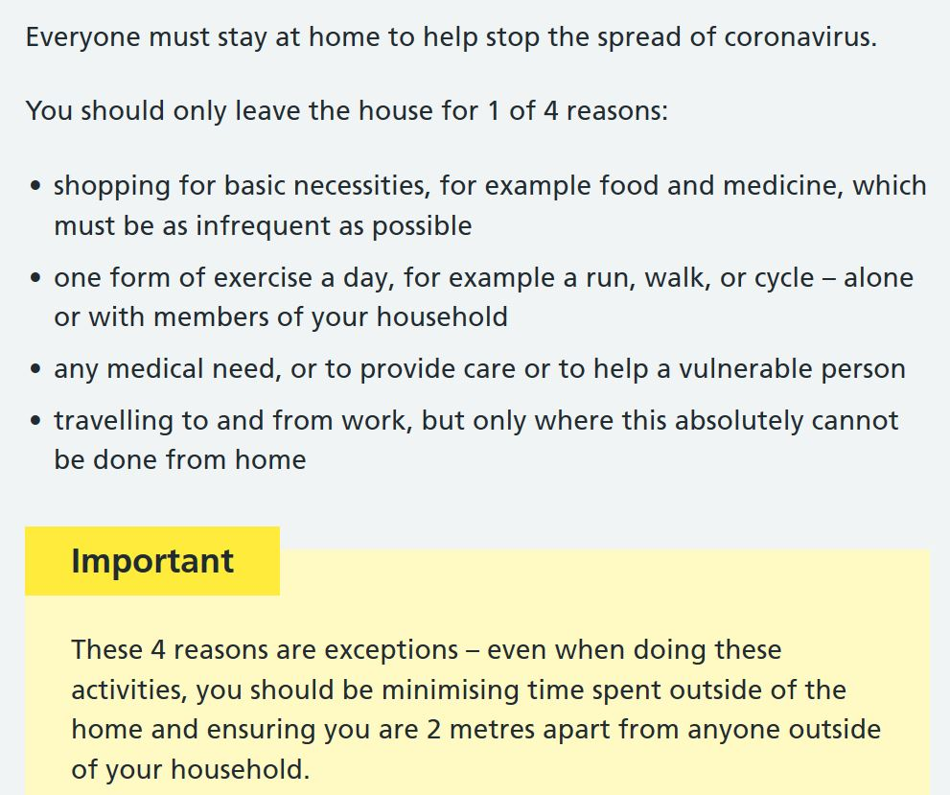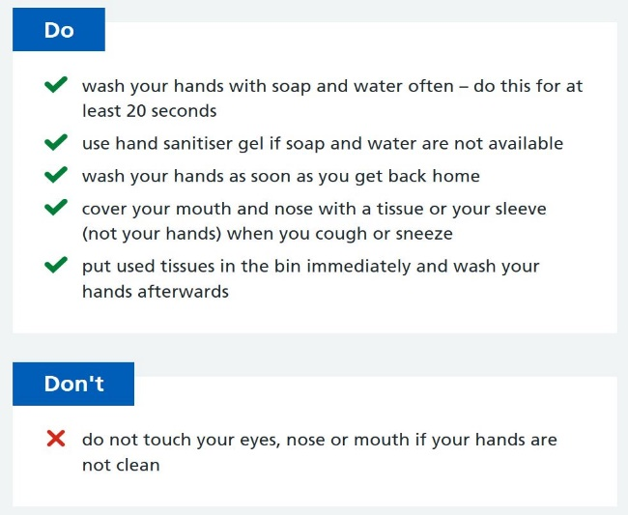

2nd April 2020

Hello,

Day eleven of LOCKDOWN and the covid19 or corona virus has certainly impacted on all our lives – it does not discriminate! Being connected, being kind and helping each other is never so important than it is now.

This has been demonstrated across the district of Tain or ward 7, where we have witnessed people, groups and agencies coming together and supporting each other in these strange times, which will go on for months to come.

We are working with the authorities to coordinate support to the vulnerable members of our community. If you are classed as a vulnerable person, if you require business support or information about school closures please call the free Highland Council number 0300 303 1362.

Not on Facebook but want to keep up to date with what’s happening in the area then please check out our website on www.tainddtrust.com, call us on 07851958823 or email us on info@tainddtrust.com.

Lastly, please keep your mind busy and stay in touch with people. Phone a friend or family member; a kindly word; How is everyone? Do you need anything? Do you know of anyone who might need help? - easy questions but so worthwhile. If someone needs help give them the helpline 0300 303 1362 this number will filter down to volunteers in your community.

Take care and stay safe but stay connected.

